SIMATS ENGINEERING

CONTINOUS INTERNAL ASSESSMENT- SHORT ANSWER TEXT
COURSE NAME: DATABASE MANAGEMENT SYSTEMS
COURSE CODE: CSA05 1 q

COURSE OUTCOME COVERED
COI: Analyze DBMS architecture, different data models, schema types, and design ER/EER diagrams, relational schemas for case-based scenarios by identifying entities and relationships.
(BLI, BL2)

Questions:05 Total marks: 100
Annexure A

SHORT ANSWER TEXT

Code of Conduct:

I (Name jeevika . kReg No 192571060 ) certify that this submission is my original work and that I have adhered to the guidelines specified for this assessment.
I understand that any violation of academic integrity rules will result in disciplinary action.
Signature of the student:

ANNEXURE
SHORT ANSWER TEXT
QUESTIONS
Q.NO  1 | Question | Bloom's Level
Q.NO  1 | Vehicle Management System  A transportation company maintains a database for managing different types of vehicles. Every vehicle has common information such as Vehicle ID, Registration Number, Manufacturer, Model, Year, and Purchase Price. The company classifies vehicles into two specialized categories: Car and Truck. A Car has additional attributes such as Number of Doors, Fuel Type, and Seating Capacity, while a Truck has atfributes such as Load Capacity, Truck Type, and Number of Axles. Both Car and Truck inherit the common afributes of the Vehicle entity through a specialization/generalization relationship. The specialization is disjoint, because a vehicle is classified as either a Car or a Truck, and it is total, because every vehicle in the system must belong to one of these two categories. Based on these requirements, construct an EER diagram showing the Vehicle supertype, Car and Truck subtypes, inherited attributes, specialization constraints, primary keys, and appropriate relationships.  Tasks  I. Identify the super-type and subtypes.  - Identify the common attributes of Vehicle.  - Identify the specialized attributes of Car and Truck.  - Specify the primary key of Vehicle and show its inheritance by the subtypes.  - Represent the ISA specialization relationship.  - whether the specialization is disjoint or overlapping.  - Specifr^{r} whether the specialization is total or partial.  - Consü-uct the complete EER diagram using appropriate EER notation. | BLI — Remember
2 | Bank Management System  A bank management system maintains information about customers, bank accounts, branches, employees, transactions, loans, and loan payments. Each customer is identified by a unique Customer ID and may hold one or  more accounts such as Savings or Current Accounts. Each account has atffibutes such as Account No, Account Type, Balance, and Opening Date and is maintained by a particular bank branch. A branch is identified by Branch ID and stores Branch Name, Location, and IFSC Code. Each branch employs several employees, with details such as  Employee ID, Employee Name, Designation, and Salary. Customers can | BL2 — Understand

perf011ii multiple transactions such Its deposits and withdrawals, where Transaction ID, Transaction Date, Tlllnsltctlon lype, and Amount arc recorded. A customer may also apply loans, With details Including Loan ID, Loan Type, Loan Amount, Interest Rate, and Loan Status, Loan payments are tx•cotxled using Payment ID, Payment Date, and Payment Amount. Based on these requirements, Identify the entitles,
attributes, primary keys, and relationships With appropriate cardinalities, and constmct a complete ER diagram for the Bank Management System
Tasks:
l. Identify the major entities.
- List suitable attributes for each entity.
- Specify the primary key of each entity.
- Identify relationships among the entities.
- Specify the cardinality of each relationship.
- Constlllct the ER diagram using appropriate entities, attributes, relationships, and cardinalities.
3 | Ecommerce Website  An E-Commerce Website maintains information about customers, products, orders, payments, and deliveries. Each Customer is identified by a unique Customer ID and has attributes such as Name, Email, Phone, and Address. Customers can browse and purchase different Products, where each product has a unique Product ID, Product Name, Price, Stock Quantity, and Description. Products are classified into different categories such as Electronics, Clothing, and Grocery, where each category may have its own specialized attributes. A customer can place multiple Orders, and each order is identified by Order ID with attributes such as Order Date, Order Status, and Total Amount. An order may contain multiple products, and the Quantity and Unit Price ofeach ordered product must be recorded. Each order is associated with a Payment, containing Payment ID, Payment Date, Payment Mode, and Payment Status. The order is also associated with a Delivery, containing Delivery ID, Delivery Date, Delivery Status, and Delivery Address. Based on these requirements, construct an EER diagram using specialization/generalization for product categories and show the appropriate entities, attributes, relationships, keys, and cardinalities.  Tasks  l . Identify the major entities: Customer, Product, Category, Order, Payment, and Delivery.  - Identify the appropriate attributes and primary keys.  - Model the Order—Product relationship and include Quantity and Unit Price as relationship attributes.  - Apply specialization/generalization to classify Product into suitable subtypes.  - Show the inherited attributes of the Product subtypes. | BL2 — Understand

- whether the IS disjotntloverlapplng and total/partial
- Represent the relationships between Customer-Order, OrderPayment, and Order—Delivery
- Specify suitable cardinalities for all relationships.
- Construct a complete EER diagram using standard EER notation.
Hospital Management System — EER Diagram
A hospital management system mamtams information about patients, doctors, nurses, departments, appointments, treatments, and medical records. Every hospital staff member has common attributes such as Staff ID, Name, Address, Phone, and Salary. The hospital staff is specialized into Doctor, Nurse, and Administrative Staff, where each subtype has its own specific atüibutes. A Doctor has attributes such as Specialization and License Number, while a Nurse has attributes such as Qualification and Shift. The hospital also maintains Patient information including Patient ID, Name, Date of Birth, Gender, and Contact Number. A patient may have multiple medical records, but each Medical Record is dependent on a particular patient for its identification and is therefore modeled as a weak entity with attributes such as Record Date, Diagnosis, and Treatment Details. Patients can consult doctors through Appointments, and doctors can provide treatments to patients. The hospital is organized into several departments, with doctors assigned to specific departments. Based on these requirements, design an
4 EER diagram incorporating specialization/generalizatlon, inheritance, BL2 — Understand weak entities, relationships, and appropriate cardinalities.
Tasks
- Identify the major entities such as Staff, Patient, Department, Appointment, and Medical Record.
- Apply specialization/generalization to represent:
o Staff— Doctor o Staff— Nurse o Staff—y Administrative Staff

- Show the inherited atfributes of Doctor, Nurse, and Administrative Staff from Staff.
- Identify the specific attributes of each subtype.
- Represent Medical Record as a weak entity dependent on Patient.
- Identify the partial key of the weak entity.
- Represent the identifying relationship between Patient and Medical Record.
- Model the relationships among Doctor, Patient, Appointment, and Department.
- Specify appropriate cardinalities and participation constraints.

- Constlllc't complete EER diagram spectaltnnt10tY/gener,11vat10t1 and weak-entity notation
Database Administrator (DBA)
A Database Administrator (DBA) is responsible for managing, maintaining, securing, and ensuring the reliable operation Of an organization's database systems. In a large organization. databases contain critical Information such as customer records, employee details, financial transactions, inventory, and business operations. The DBA ensures that this data is stored efficiently, remains accurate and consistent, and is available to authorized users whenever required. The DBA is also involved In database design, installation and configuration, user and ac^{cess} management, security, backup and recovery, performance momtonng, storage management, and troubleshooting. In addition, the DBA monitors database performance and identifies problems such as slow queries, excessive resource usage, or storage limitations. The DBA implements appropriate backup and recovery strategies to protect data against hardware failures, software errors, accidental deletion, and other disruptions. Based
5on these responsibilities, explain the role of a DBA and discuss the major BLI — Remember responsibilities associated with the position.
Tasks
l. Define the role of a Database Administrator (DBA).
  - Explain the DBA's responsibility in database design and Implementation.
  - Describe database security and user access control.
4, Explain backup and recovery management.
  - Discuss database performance monitoring and optimization.
  - Explain data integrity and consistency management.
  - Describe storage and database maintenance activities.
  - Explain the DBA's role in troubleshooting and disaster recovery.
  - Discuss user and privilege management.

  - Explain how a DBA ensures database availability, reliability, and


RUBRICS FOR CALCULATION:
Criteria | Weightag e | Level 4  (Exemplary) |  | Level 3  (Proficient) |  | Level 2  (Developing) | Level I  (Beginning)
Concept  Identificati  on | 300/6 | Demonstrates clear and complete understanding of the conce t |  | Good understandin  g with minor gaps | Basic understanding with some misconceptio ns |  | Poor or  Incorrect understandi n
Linkages |  | Completely correct answer with no errors |  | Mostly correct with minor errors | Partially correct with noticeable errors |  | Incorrect or irrelevant answer
Organizatio n |  | Correctly applies concepts to solve the question/proble  m |  | Applies concepts with minor mistakes | Limited or partially correct application |  | No or incorrect application
Integration of  Literature | 15% | Covers all required parts of the uestion |  | Covers most parts with minor omissions | Covers only some parts |  | Incomplete or missing response
Clarity |  | Clear, concise, and wellorganized answer |  | Understanda  e with minor issues | Somewhat unclear or poorly structured |  | Difficult to understand

o ,
l) \lJutlz dlåqran
fßR oliÐwm Tcpratnbf attflbLdD,
4peu'all'/žaÐon and înhL^{L}t/+ancz
"pcttype Whi^{t}t-Il
JL11Lt5pu (Mt anol 17111k
Commem adb)buiJ LUL/dz:
VcJtÌcü  )
Num b



ManufdttLLZu
PlÐdLl
Pr/a
Specìaðh/d atfribLLbJ.'
NUn/oc€- DÐOU/ Type/ Jeat)'ng- Capacity
Tv9tuck : Load- (apac/tY/ Truck- Type Numbut— 96 - ,9zZcg JpecÈŒI/øatž0n (OnJhaìJd(:
Düqþl'nt î h VJt1tclL (dL,1 be a Cot Oua+/(ldkž but not both '
Total: Vchìcle bcLOV9 eh tLcUe
/JLlbhJpu ,
Inhutttantz : Jubkypu ;whDfJt dhß

' -- D ^{l} aq-rcyn
ГК dlhqqayn T(lUttLtL0 Иц (ldtH1'z


дис{ а da/7baJt
6bdt7h/ | PtTl'hwb{
Сиь/рупьч |   (РК)? Напи Но!
Ptt@Lll4t | Ptcouvtt- ЛЬ СРЮ, lttouvlt- Тире, Вдари Ореи/из- 90,6
ВтаисЬ | ВтаидЬ— 1 D (РК9/ ВбаиИ- ЛЬ40И/  (9е$/774+Н-и СКс — •
fmpl¶ | gmplgpg - 2 D ( РК), gynplogee Тате    ddazg
Тъчдшаснђ% | TutazacH'n— ТD С РК)/ TUkamat7L/e-„
Оа@? ТуаиЈсиНе-р- Туре / Pmun.d .
[ип- сркР/<2, L&ap- туре / 

Ртгии+/ Tvt00Jt—Rntt/ - А/а+-д
Rdatl)hJuAA 't7Z8
Ptt8LQtt : М: Л/ Р(свиьсес l•o N
(vh8wu-  с- 1: CvcJ*P4WJf доща :
е- 2 раю Pagnunt

Wehh)te
wtbd/te 0/-101,1" (Udhomvu "/Ð
Produtb 04/11/'/u makŒ puff/4/12zt// dctìwuvs
\ttå/'k Wlbd/'te
bouta ond JŒ'(IL ruducå
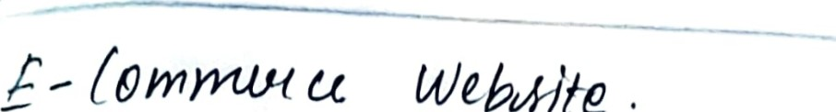
Ðdd /tunu {9 (nd avd chukout
a
upddb
U-vtk

/ozømct lutteuðu-( ? /d3mtnt Vu oqdUu and
dLL/VØøad

4 • k)ÿ5pì+aL management Jt/Shem
1/10dpjbLt Wl)ífnŽ
Ihaaùdtuù,u ÙcbT1mažì6¾ about /dÐVøtJ/
0/2/0îHtþ/1(Lå Diol mldì(aZ Yeutzd/J,

Okt Ð{î0/3

/lðtabå
/9ppo/r1Ð-nent
Ned/'tLl -Rucoza

1901/44/'F1/*shaH1/Q- J?ld-åb
mak Q tiÐV-y Double ret/-arz&  reldHvø4h/þ: Dubb d/åvnonol

Pazdlål kny Øoz-htd
Tota pauHopaE044 EIÅUIÐ medJtaZ recvø/)
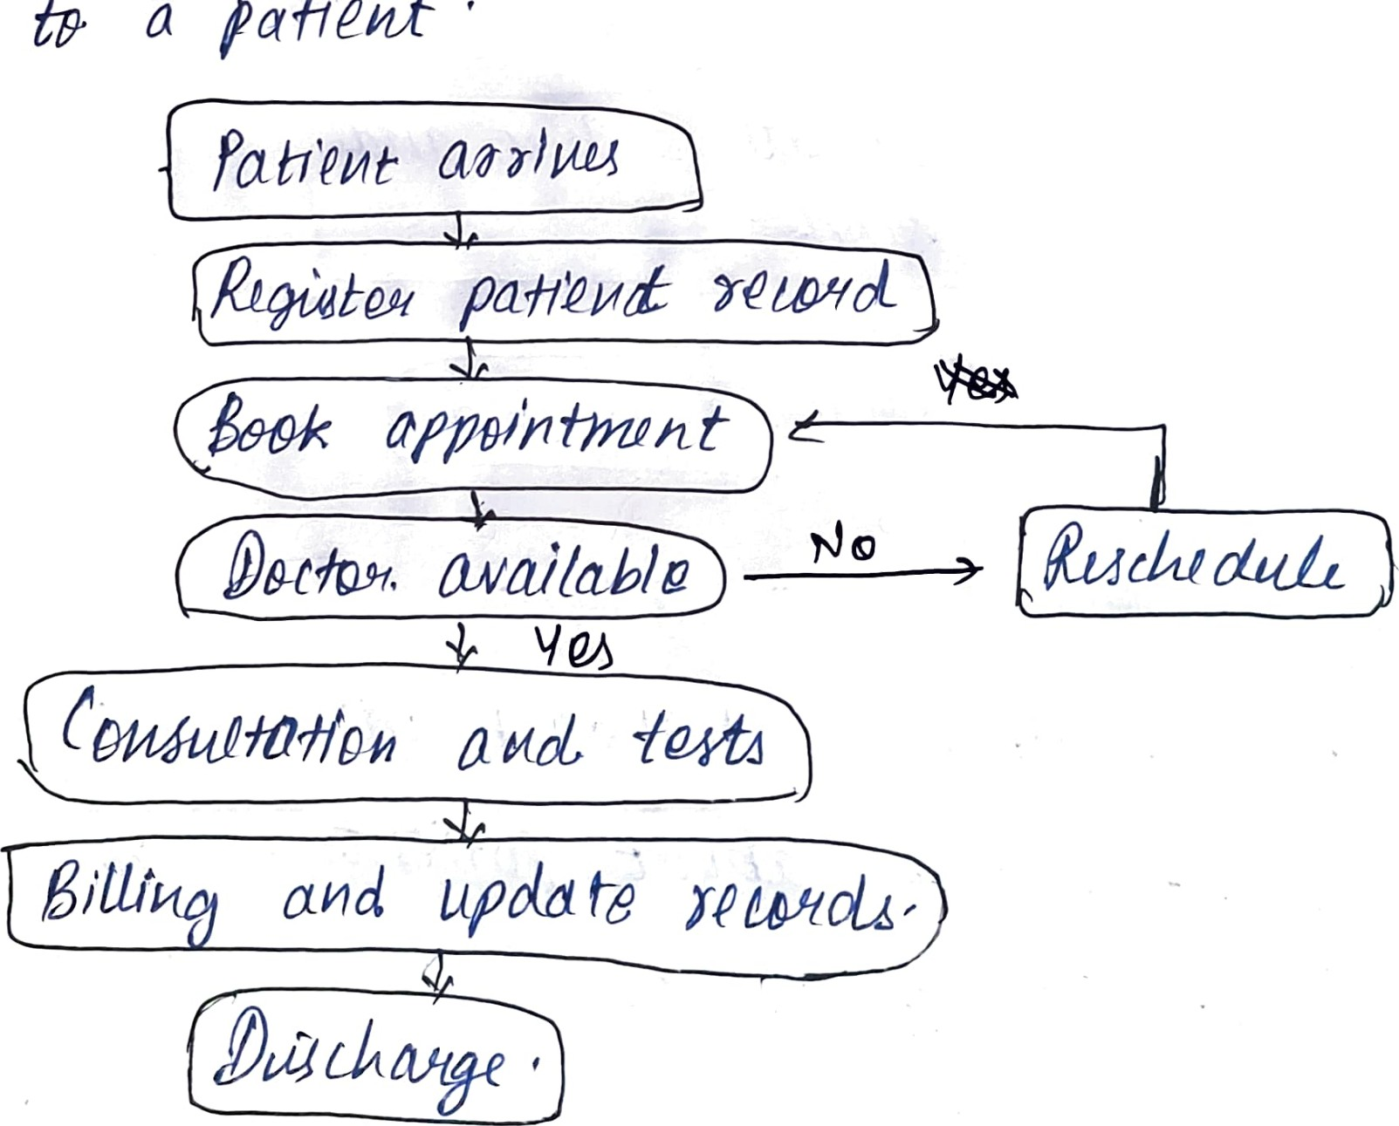
be10L¶
a
paf1þØyt

